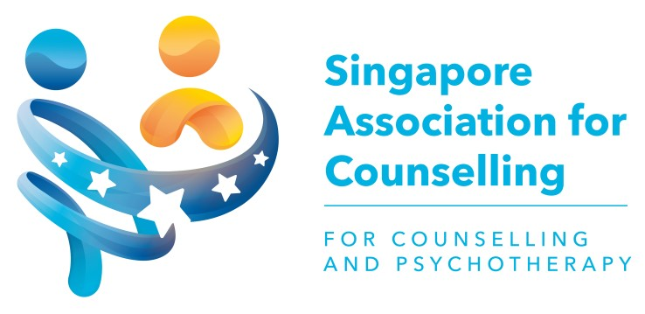
SAC Registered Counsellor
This is to certify that
Mdm Anusha Balasingham
is a Registered Counsellor
with the Singapore Association for Counselling
This certificate is valid from 1 Mar 2025 to 28 Feb 2027
and is subject to renewal.
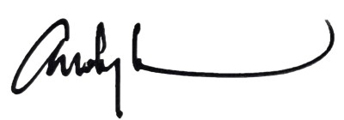
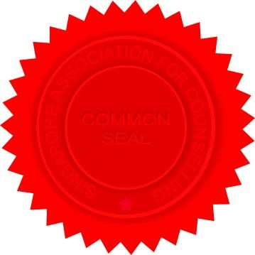
Mr Andy Lam
MMSAC RegCLR RegClinSup RSW President (2024 - 2026)
Singapore Association for Counselling
Cert. No.: 1932/2025
Acc. No.: C0955

